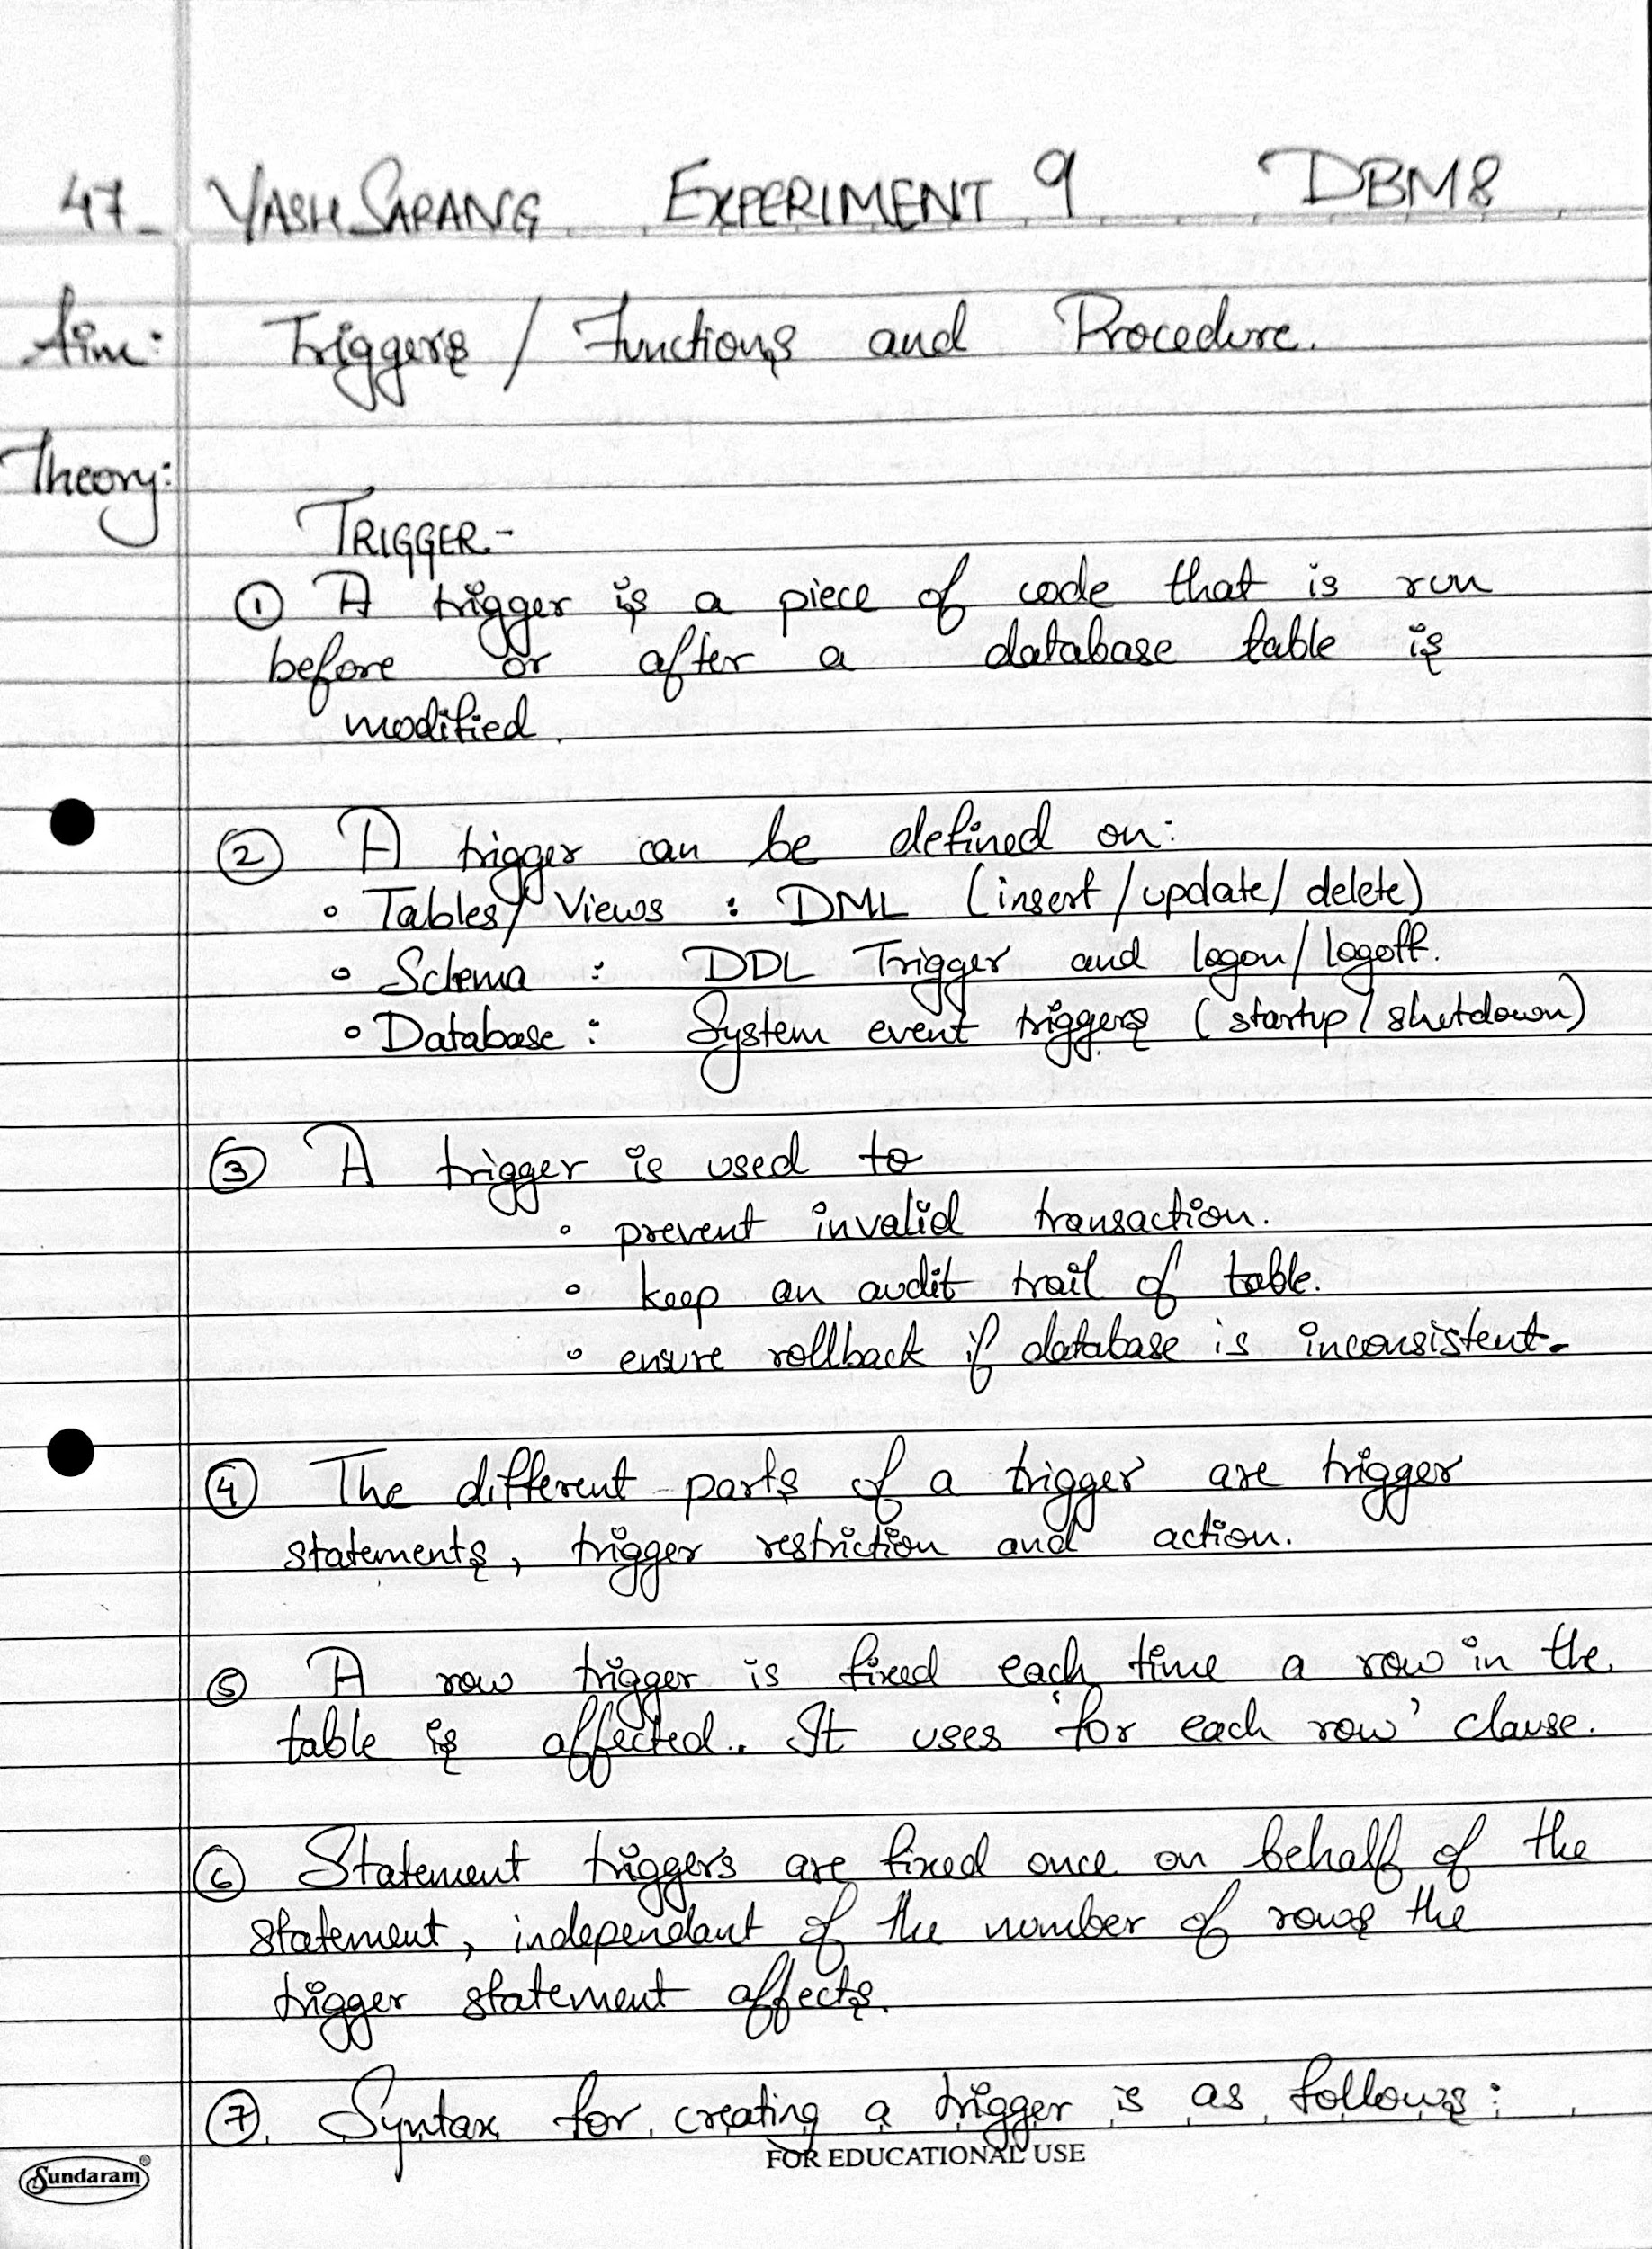

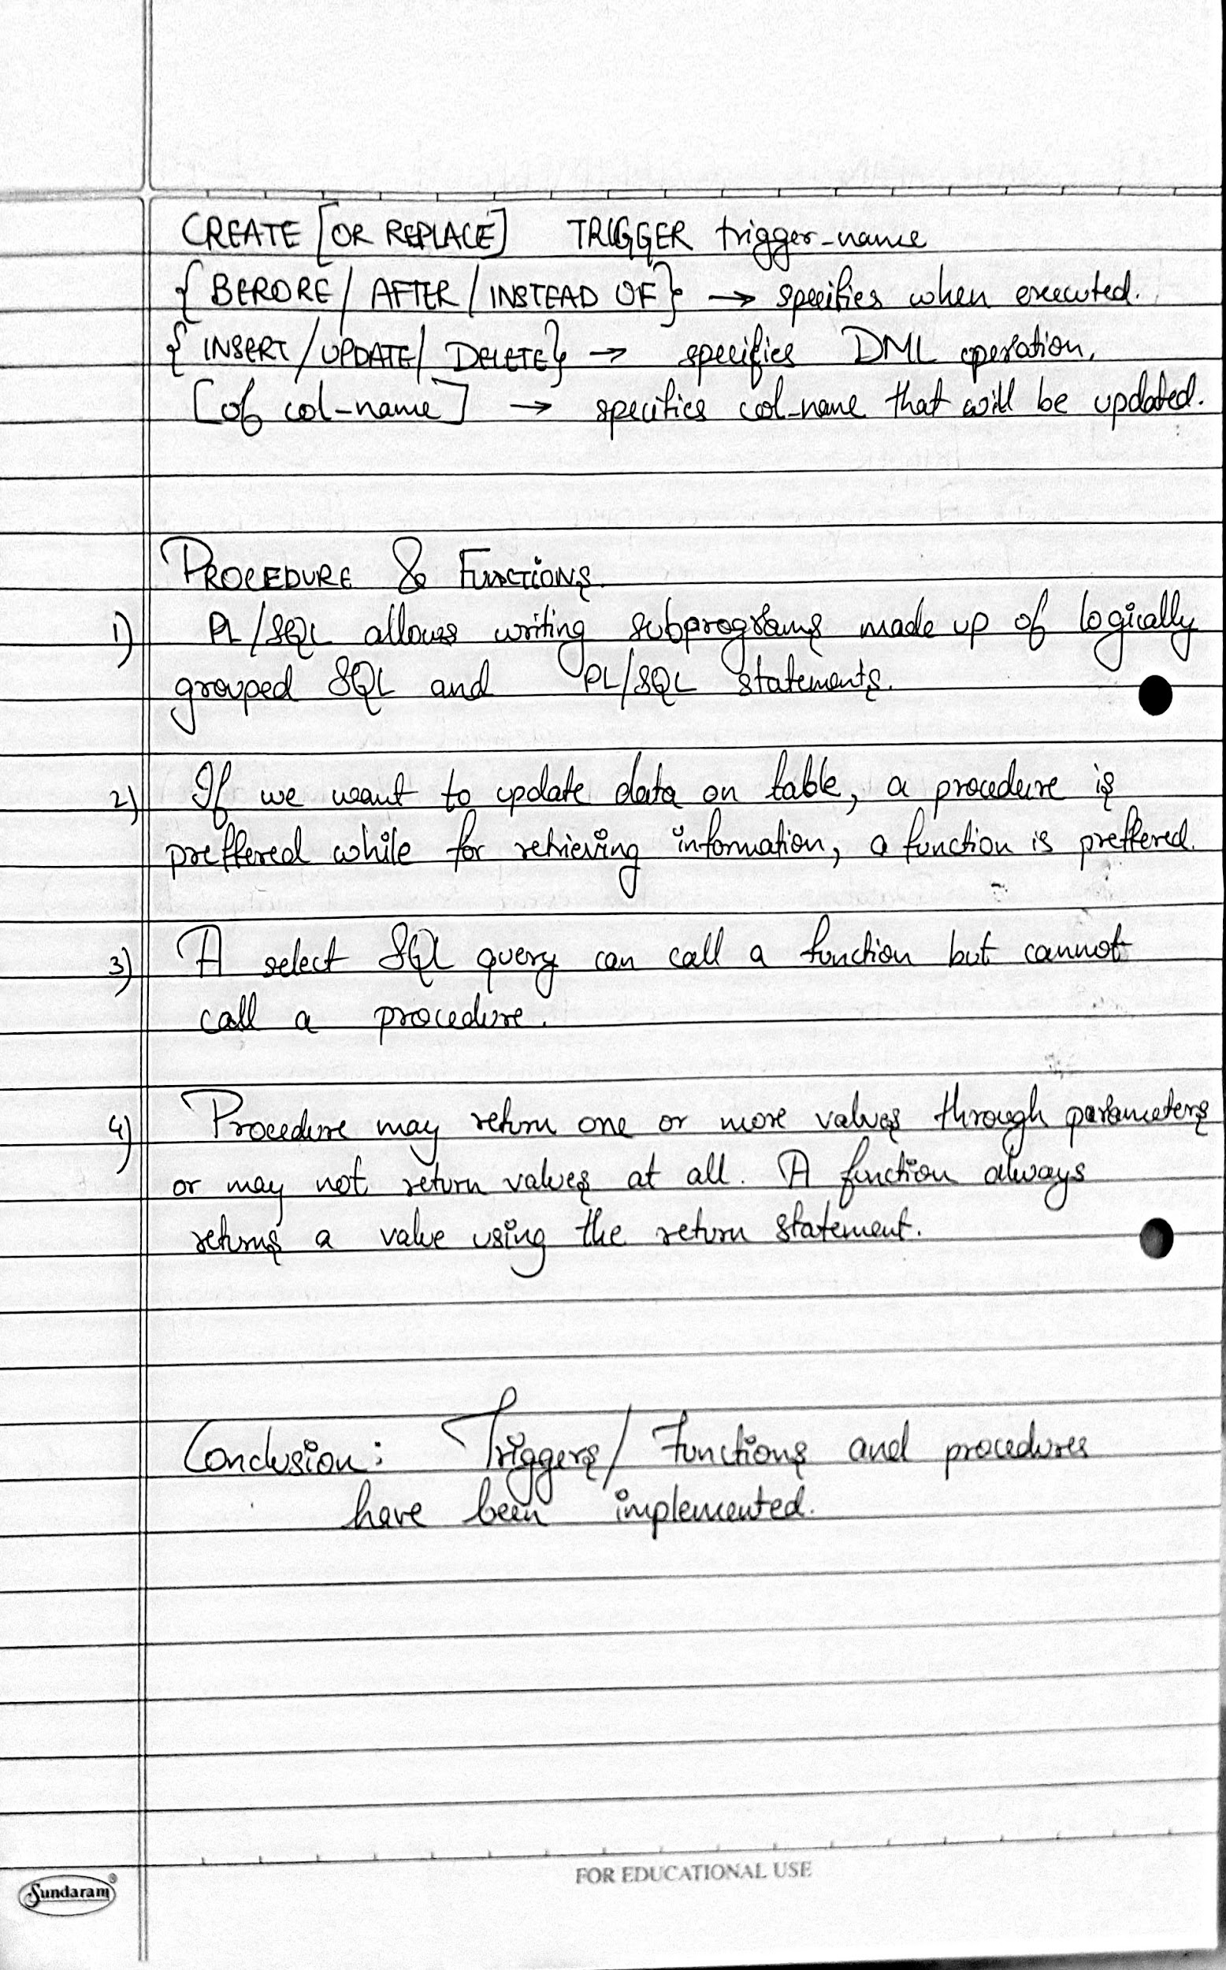

SQL QUERIES:

1. Create a trigger that fires before inserting or delete of a row in the emp table and displays the count of rows.

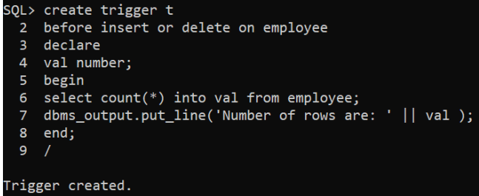

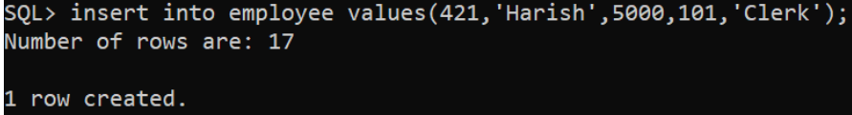

2. Create a trigger that stops the user from entering Dept no in emp table if that dept no doesn’t exist in dept table. The trigger should display the contents of dept table.

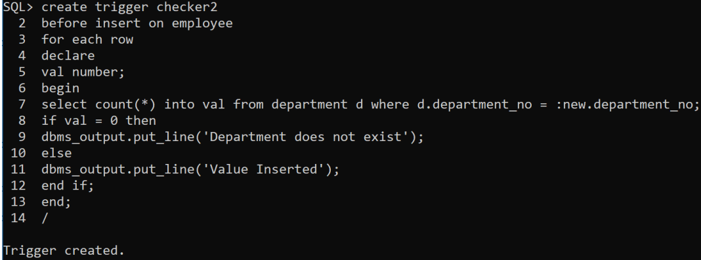





3. Write a procedure that: Accepts department number and percentage of raise in sal Updates the sal of all those employees under that department

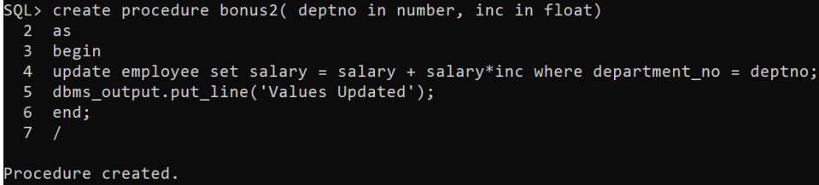

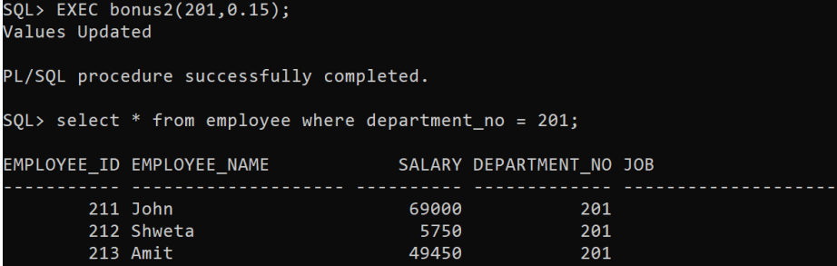

4. Write a function that accepts: Dept no and returns the total sal of all employees in that department.

